ALIEN INVASIVE PLANTS NEEDING ATTENTION ONGOING

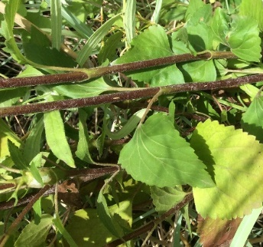  Crofton weed | 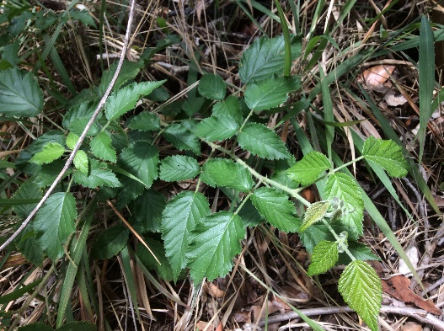  Bramble – please pull out? These prickly bushes are very unpleasant to walk through! | 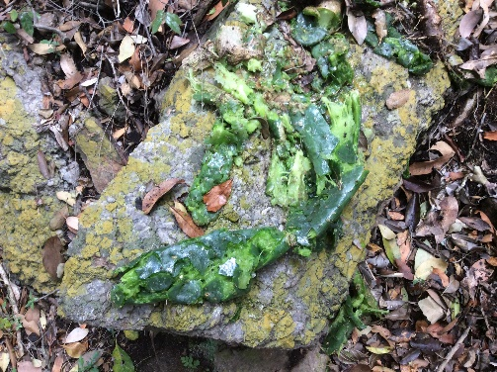  Jointed cactus and Prickly Pear needs thorough extermination as shown above! Rock is a good tool
Crofton weed has typical triangular leaves, grows in water, has reddish stem and stinky stem and leaves. There are many at the top of Hamerkop Kloof, even near the top spring. Aleck presently can only work on the declared weeds in the Hamerkop property, as our neighbour Jacques Cilliers is very worried having strangers on his property.

